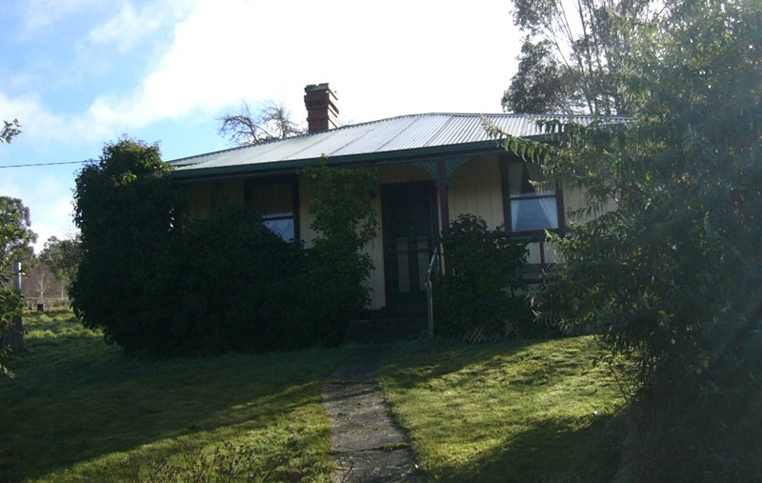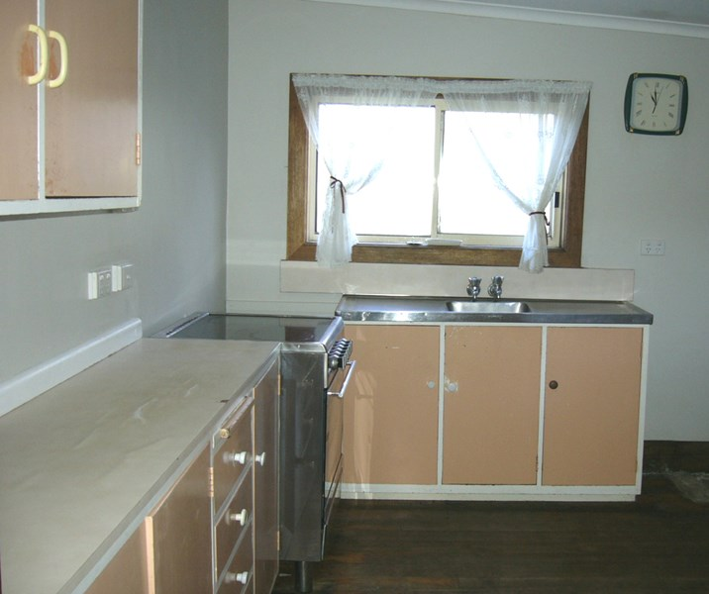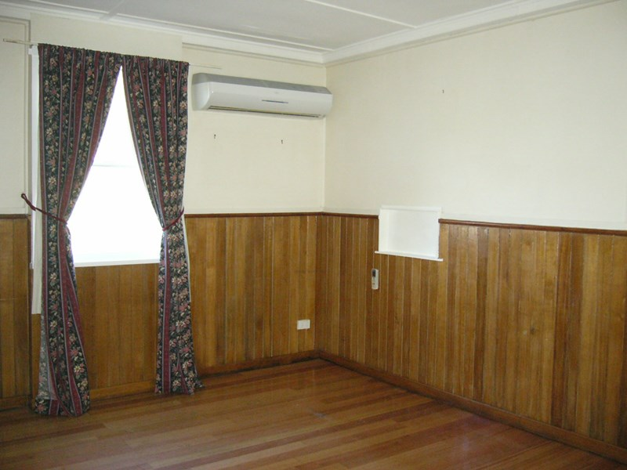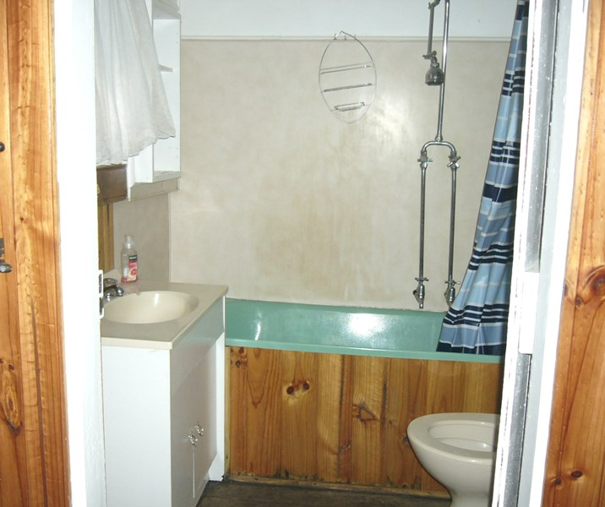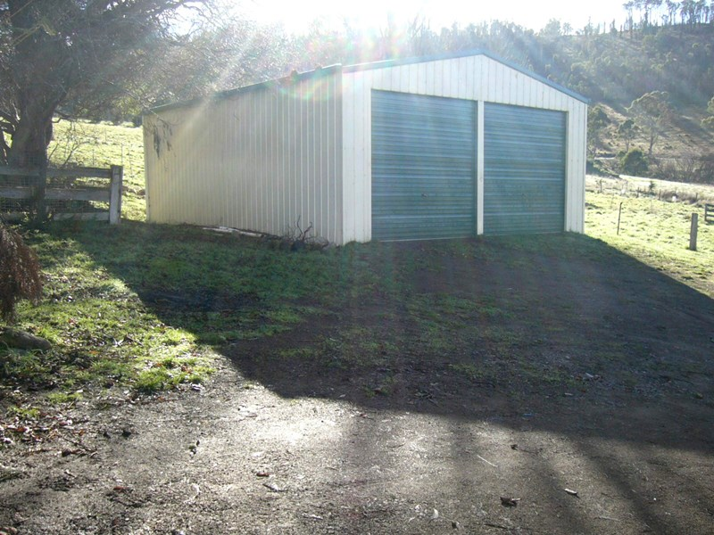

**1188 Ellendale Road, ELLENDALE TAS 7140**

**Rural Property with Stables & Dressage Arena**

This 3 bedroom picturesque cottage style home is located in Ellendale. The property is heated throughout by a reverse cycle heat pump in the lounge area. The property is on 9 acres approx. with stables and a dressage ring. Rent $240 per week Bond $1160. Pets Negotiable. Available Now! Please contact our office to arrange an inspection.**Features**

* Air Conditioning
* Fireplace(s)
* Garden
* Secure Parking

**$240 per week**

